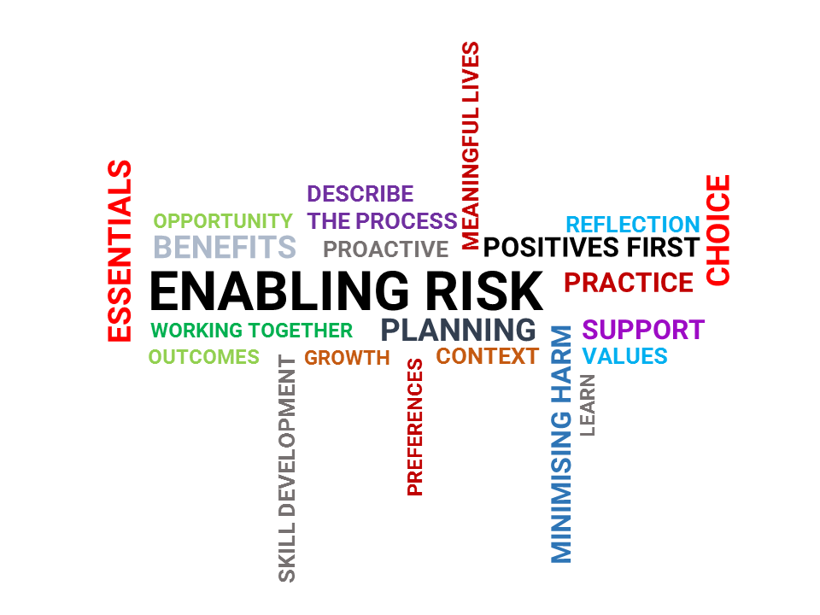

ENABLING RISK: PUTTING POSITIVES FIRST
Risk Enablement Online Learning Resource

ACTIVITY WORKBOOK

www.enablingriskresource.com.au

CC BY-NC-SA
This work is licensed under a Creative Commons Attribution-NonCommercial-ShareAlike 4.0 International License.

How to cite this resource:
Bigby, C., Douglas, J.M., & Vassallo, S. (2018). Enabling Risk: Putting Positives First. An online learning resource for disability support workers. Retrieved from: www.enablingriskresource.com.au

Table of Contents

MODULE 1: Introduction to Risk 4
ACTIVITY 1: Reflecting on my risk-taking behaviour 5
MODULE 2: Enabling Risk for the People You Support 10
ACTIVITY 2.1: Thinking about Risk Enablement 11
ACTIVITY 2.2: Maggie’s Cup of Tea 12
MODULE 3: The 4 Essentials of Risk Enablement 15
ACTIVITY 3.1: Josh’s Big Trip 16
ACTIVITY 3.2: Tom’s Business Idea 18
ACTIVITY 3.3: Gloria goes Rock Climbing 20
ACTIVITY 3.4: Josh wants a Phone 23
ACTIVITY 3.5: Dan’s Trek 25
ACTIVITY 3.6: Tanya’s Date 27
Extra Activity 3.2: David’s Skateboard 29
Extra Activity 3.5: Amanda wants to walk her dog 32
Extra Activity 3.6: Susan’s Smoothie 35
MODULE 4: Risk Enablement in Action 39
Case Scenario: Cody is Moving out of Home 40
ACTIVITY 4.1 42
Case Scenario: Angela’s Birthday Cake 44
ACTIVITY 4.2 47
ACTIVITY 4.3: Shane’s New Start 49
ACTIVITY 4.4: Chloe Catches the Train 54
ACTIVITY 4.5: Scissors for Romeo 59
MODULE 5: Being Someone who Enables Risk 65
ACTIVITY 5.1: Experiences from risk enablement 66
ACTIVITY 5.2: Application 68
ACTIVITY 5.3: Organisational Process and Support 73

MODULE 1: Introduction to Risk

ACTIVITY 1: Reflecting on my risk-taking behaviour

This activity asks you to reflect upon risks you have taken or were prevented from taking in your own life. As part of this process, you will consider the positive and negative outcomes associated with the risk and the categories to which they belong.
This activity has 3 separate questions. Please read the instruction carefully, then complete each of the tables below.
- Think of a time when you CHOSE to undertake a risky activity. Write the activity at the top of the table, then complete the sections. A completed example has been provided for you.

COMPLETED EXAMPLE
Write a risky activity you did:
Travelled alone overseas for 6 weeks
List some positive outcomes that came from having done this activity | Tick the box that best fits the category your positive outcome relates to
 | Physical Health & Safety | Psychosocial Well-Being | Financial
Met new people
Learned a different language
Became fit from all the walking I had to do
Felt a sense of achievement
List some negative outcomes that came from doing this activity | Tick the box that best fits the category your negative outcome relates to
 | Physical Health & Safety | Psychosocial Well-Being | Financial
I was homesick for the first few weeks
Spent more money than I had planned
Explain whether you will undertake this ‘risky’ activity again.
Yes, because I learnt a lot about myself and how to travel alone.
Are there any changes you would make or anything you would do differently the next time?
Make sure more than one person at home had a copy of my itinerary.

YOUR TURN Now, complete this table for a risky activity that you chose to participate in.
Write a risky activity you did:
List some positive outcomes that came from having done this activity | Tick the box that best fits the category your positive outcome relates to
 | Physical Health & Safety | Psychosocial Well-Being | Financial
List some negative outcomes that came from having done this activity | Tick the box that best fits the category your negative outcome relates to
 | Physical Health & Safety | Psychosocial Well-Being | Financial
Explain whether you will undertake this ‘risky’ activity again.

Are there any changes you would make or anything you would do differently the next time?

- Think of a time when you CHOSE to NOT participate in a risky activity. Write the activity at the top of the table, then complete the sections. A completed example has been provided for you.

COMPLETED EXAMPLE
Write a risky activity you chose NOT to participate in:
I declined an employment opportunity that was interstate
List some positive outcomes that came from not participating in this activity | Tick the box that best fits the category your positive outcome relates to
 | Physical Health & Safety | Psychosocial Well-Being | Financial
Was easier to keep in contact with my friends
Did not have to move to a new location
Did not have to leave my family
I enjoyed my current job
List some negative outcomes that came from not participating in this activity | Tick the box that best fits the category your negative outcome relates to
 | Physical Health & Safety | Psychosocial Well-Being | Financial
Did not develop new skills
Did not meet new people
Did not experience living in another location
Thinking about it now, would you have changed your choice? Explain.
The timing was the issue. If the offer had been made a few years earlier, I would have taken it. But I was now in a job I liked. So, yes, I would have made the same choice. I had spent some time researching the job description I was being offered, and it didn’t appeal to me at that point in time.

YOUR TURN Now, complete this table for a risky activity that you chose NOT to participate in:
Write a risky activity you chose NOT to participate in:

List some positive outcomes that came from choosing not to participate in this activity | Tick the box that best fits the category your positive outcome relates to
 | Physical Health & Safety | Psychosocial Well-Being | Financial
List some negative outcomes that came from choosing not to participate in this activity | Tick the box that best fits the category your negative outcome relates to
 | Physical Health & Safety | Psychosocial Well-Being | Financial
Thinking about it now, would you have changed your choice? Explain.

- Think of a time when you were PREVENTED from undertaking a ‘risky’ activity. For example, it could have been a friend, family member, partner or employer who discouraged you or prevented you from doing something you wanted to do. A completed example has been provided for you.
Write the activity at the top of the table, then complete the sections.

COMPLETED EXAMPLE
Write a risky activity you were PREVENTED from participating in:
My partner prevented me from learning how to ride a motorcycle. She was concerned I would get hurt.
List some positive outcomes that came from being prevented from doing this activity | Tick the box that best fits the category your positive outcome relates to
 | Physical Health & Safety | Psychosocial Well-Being | Financial
Did not get injured
Did not pay for driving lessons
List some negative outcomes that came from being prevented from doing this activity | Tick the box that best fits the category your negative outcome relates to
 | Physical Health & Safety | Psychosocial Well-Being | Financial
Did not learn how to ride a motorcycle
I felt disappointed and frustrated that I wasn’t supported
I was dependent upon public transport
Now that you have had this experience, would you prevent another person from engaging in a risky activity? Explain
No, I wouldn’t prevent another person from doing what they wanted – I understood that they cared, but I found it frustrating to deal with. As a matter of interest, years later, when my partner and I were no longer in a relationship together, I then learnt how to ride a motorcycle.

YOUR TURN Now, complete this table for a risky activity that you were prevented from participating in:
Write a risky activity you were PREVENTED from participating in:

List some positive outcomes that came from being prevented from doing this activity | Tick the box that relates to the category your outcome relates to
 | Physical Health & Safety | Psychosocial Well-Being | Financial
List some negative outcomes that came from being prevented from doing this activity | Tick the box that best fits the category your negative outcome relates to
 | Physical Health & Safety | Psychosocial Well-Being | Financial
Now that you have had this experience, would you prevent another person from engaging in a risky activity? Explain

If you have any questions about this module, or would like some further guidance about the activities, you can send an enquiry using the Contact Form. Suggested responses to the activities are provided in the Resources section. ​

MODULE 2: Enabling Risk for the People You Support

ACTIVITY 2.1: Thinking about Risk Enablement

- Complete the table provided below by re-writing the missing statements. A completed example is provided for you at the top.
The language of risk enablement
Risk minimisation statement | Risk enablement statement
“Tie up your shoelaces properly, Stuart. You’ll trip and hurt yourself.” | “Stuart, let me know if I can help you tie up your shoelaces.”
“I’ll put the cake in the oven, Shelley. It’s too dangerous for you.”
“Simon wants to ride a horse? No. That’s far too risky. He’s not allowed to ride horses.”
 | “Learning how to play the piano sounds like a great idea, Katie. Let’s see what we can do to make it happen.”
“What? Mario wants to run a marathon? Well, that’s just not realistic, is it?”
 | “Claire, would you like to walk with me to the corner shop so we can get a coffee.”
“I’ll manage the money, David. It’s best if I do this for you.”
‘You can’t go outside today. It’s too hot and you’ll get sunburnt.”
“No, there’s no time to bake a cake today, Greg. I’m too busy.”
 | “Craig, would you like to cut up the vegetables for dinner? Let me know if you need help.”

ACTIVITY 2.2: Maggie’s Cup of Tea
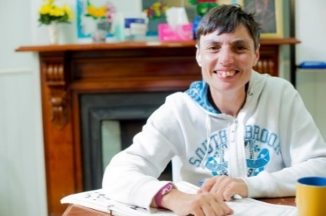

Read about Maggie’s scenario below, then answer the
questions.

Maggie’s Cup of Tea
Maggie enjoys having cups of tea throughout the day. She has limited strength in her arms to lift a heavy kettle. Her disability support worker, Carol, was scalded with boiling water when she was a child and so she is concerned about Maggie burning herself.
The kettle is kept in a locked staff office at all times. When Maggie wants a cup of tea, she has to wait for staff to make it for her. Sometimes, staff are busy supporting other residents and so Maggie can be left waiting for some time. Other times, staff forget to bring Maggie her cup of tea.
- What is considered to be the “risk” for Maggie.
Write your response in the box below:

- List all the things that are ‘getting in the way’ of enabling Maggie to make a cup of tea.
Write your response in the box below:

- What has happened to the balance of protection and choice in Maggie’s situation?

Write your response in the box below:

- Write all the ways that you think Maggie’s risk can be minimised, so as to enable her to make her cup of tea. An example has been provided for you.

Write your response in the box below:
- An instant boil kettle can be purchased. This type of kettle has a button on it which, when pressed, will pour a fixed amount of hot water for one cup. This way, Maggie does not have to lift a full kettle with boiling water. (click here for an example of an instant boil kettle)

- Thinking about the work that you do, and the experiences that you have had, can you remember a scenario when a person with intellectual disability was so protected from possible harm that they had little choice? Describe what happened. What did you think about this?

Write your response in the box below:

If you have any questions about this module, or would like some further guidance about the activities, you can send an enquiry using the Contact Form. Suggested responses to the activities are provided in the Resources section. ​

MODULE 3: The 4 Essentials of Risk Enablement

ACTIVITY 3.1: Josh’s Big Trip

Watch the video “Josh’s Big Trip” and then answer the questions.
Watch the video: Module 3 Josh’s Big Trip on the website. It will get you thinking about what it means to be person centred and how it is important to enabling risk.

- Josh is excited about going on a trip to Newcastle, but just as the group is about to leave, he changes his mind about going. Why does Josh react in this way?
Write your response in the box below:

- Leon, Josh’s Disability Support worker, phones Pete to seek advice. Instead of making a phone call, what could Leon have done to further understand Josh’s choice?
Write your response in the box below:

- Thinking about the work you do, what are some of the ways in which you practice being person centred when supporting a person with intellectual disability? Examples have been provided for you.
Write your response in the box below:
- I listen carefully to what the people I support want.
- The posters the person I support puts up in their room tell me what they are interested in.

ACTIVITY 3.2: Tom’s Business Idea

Watch the video: Module 3 Activity 3.2 Tom’s Business Idea on the website to see an example of how to put positives first when enabling risk.

- What is Tom’s “exciting news”?
Write your response in the box below:

- What could be the ‘risk’ in Tom’s situation?
Write your response in the box below:

- Describe how Tom’s dad demonstrates Putting Positives First when talking with Tom.
Write your response in the box below:

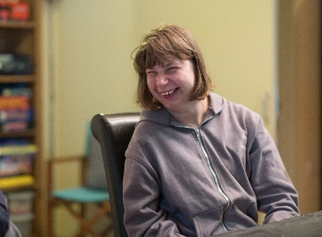
ACTIVITY 3.3: Gloria goes Rock Climbing

Read about Gloria’s scenario and then answer the questions.

Gloria is going rock climbing
Gloria is a 25 year-old woman with intellectual disability who likes trying out new sporting activities, keeping fit and meeting other people. She has low support needs. Gloria saw a documentary on television recently where people with intellectual disabilities were learning how to rock climb and she has been talking about it ever since. She is keen to get the activity booked as soon as possible.

- Identify all of the things that you would consider to be positive risks if Gloria were to go rock climbing.

Write your response in the box below:

- Identify all of the things that you would consider to be negative risks if Gloria were to go rock climbing.

Write your response in the box below:

- If you were Gloria’s disability support worker, how would you respond if you were being reactive?

Write your response in the box below:

- If you were Gloria’s disability support worker, how would you respond if you were being proactive?

Write your response in the box below:

- Thinking about the work you do, can you remember a time when you or someone you work with was reactive rather than proactive while supporting a person with intellectual disability to undertake an activity? Explain the scenario. What are your thoughts about this?
Write your response in the box below:

ACTIVITY 3.4: Josh wants a Phone

Watch the video “Josh wants a phone” and then answer the questions.
Watch the video: Module 3 Josh wants a Phone on the website. It shows an example of how to stay true to preferences.

- Why does Josh want a phone?

Write your response in the box below:

- What are considered to be the positive risks for Josh in this scenario?

Write your response in the box below:

- What are considered to be the negative risks for Josh in this scenario?

Write your response in the box below:

- Describe how Josh’s disability support worker goes about Staying True to Josh’s Preference while reshaping his choice.
Write your response in the box below:

ACTIVITY 3.5: Dan’s Trek

Watch the video: Module 3 Activity 3.5 Dan’s Trek on the website to see an example of how to Stay True to Preferences.

- What is Dan’s preference?
Write your response in the box below:

- What could be the ‘risk’ in Dan’s situation?
Write your response in the box below:

- Owen, one of the disability support workers suggests an alternative activity for Dan. What is the alternative activity and how does Dan respond?
Write your response in the box below:
Alternative Activity Suggested:

Dan’s Response:

- Tony is the disability support worker who arrives to take over the afternoon shift. What does he suggest as a way forward so that they stay true to Dan’s preferences?
Write your response in the box below:

ACTIVITY 3.6: Tanya’s Date

Watch the video: Module 3 Activity 3.6 Tanya’s Date on the website to see an example of Minimising Harm.

- Tanya has been asked out on a date by someone she met at the gym and she is excited about going. What does her mum think is the ‘risk’ to Tanya in her situation?
Write your response in the box below:

- What does Tanya want?
Write your response in the box below:

- What things does Tanya’s disability support worker ask her to think about as a way to minimise harm?
Write your response in the box below:

If you have any questions about this module, or would like some further guidance about the activities, you can send an enquiry using the Contact Form. Suggested responses to the activities are provided in the Resources section.

NEXT: Module 3: Extra Activities to extend your learning about some of the Essentials of Risk Enablement.

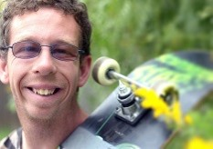
Extra Activity 3.2: David’s Skateboard

Read about David’s scenario and then answer the questions.

David’s Skateboard
David has always enjoyed riding his skateboard. He experiences great enjoyment from being able to get out and explore his neighbourhood. Skateboarding makes David feel alive, it enables him to have some independence and keeps him exercising.
Recently, David rode over an uneven path, lost balance and fell. This caused a deep graze to his elbow. The wound has taken a couple of weeks to heal fully, but David is otherwise well.
David’s disability support worker has instructed that he is to no longer ride his skateboard down the street, only in the backyard.
- Let’s think about “Putting Positives First” for David. Explain all of the positive aspects that you can think of that he would experience from riding his skateboard when and where he wanted. An example has been provided for you.
Write your response in the box below:
- David feels independent when riding his skateboard.

- David’s skateboarding has now been restricted to the backyard. Explain all of the things that you can think of that he would experience from having this change imposed on him. An example has been provided for you.
- David will lose confidence in his ability to ride his skateboard.
Write your response in the box below:
- In what other ways might David’s disability support worker have responded to this situation? An example has been provided for you.
Write your response in the box below:
- Keep David’s skateboarding routine the same.

- Thinking about the work you do, can you remember a time when you or someone you work with did not consider “Putting Positives First” while supporting a person with intellectual disability? Explain the scenario. What are your thoughts about this?
Write your response in the box below:

Extra Activity 3.5: Amanda wants to walk her dog

Read about Amanda’s scenario, then answer the questions.

Amanda wants to walk her dog
Amanda has a dog called Bob. About three times per week, Amanda takes Bob for his usual walk along the nearby foreshore. The walk usually takes about 30 minutes.
Today, Amanda’s disability support worker, Sarah, feels that it is too windy outside to walk Bob. She does not want to be out in the cold air and is concerned Bob will be hard to hold on the leash in such weather conditions. Sarah suggests that they compromise and go for a drive in her car with Bob. Amanda agrees to proceed in this way.
Sarah knows that Amanda likes milkshakes. During their drive, Sarah drives through the drive-through window at the local fast food restaurant to buy a milkshake for each of them. Sarah then parks the car in a parking bay along the foreshore, so that they can look out onto the beach while finishing their drinks. Sarah looks over at Amanda and is pleased that she appears happy. Bob is asleep.

- What did Sarah see as the risk in this situation?
Write your response in the box below:

- Do you think Sarah’s suggestion to go for a drive was in fact a ‘compromise’? Explain your thoughts.
Write your response in the box below:

- Explain whether you believe that Sarah remained true to Amanda’s preference.
Write your response in the box below:

- In what ways could Sarah have supported Amanda to take Bob for a walk?
Write your response in the box below:

- Sarah was pleased that she could see that Amanda was happy. Describe whether you think Amanda being ‘happy’ was a good outcome in this situation.
Write your response in the box below:

- Thinking about your own work as a disability support worker, can you remember a time when you or someone you work with did not stay true to your client’s preferences? Explain the scenario and your thoughts about the situation.
Write your response in the box below:

Extra Activity 3.6: Susan’s Smoothie
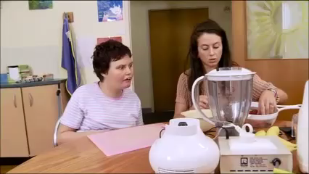
Read about Susan’s scenario, then answer the
questions. Note that this scenario is in two parts.
Only the second part has a video.

Susan’s Smoothie – Part 1
Susan likes to drink strawberry smoothies. Her disability support worker, Karen, is making one for her. Susan’s grip is weak, and Karen does not want Susan to cut herself while chopping up strawberries.
Susan would like to be involved, but instead watches while her smoothie is being prepared. She is not participating.

- What is considered to be the “risk” in Susan’s scenario?
Write your response in the box below:

- Complete the remaining blanks in the figure below to describe what is happening in Susan’s scenario with each Essential.
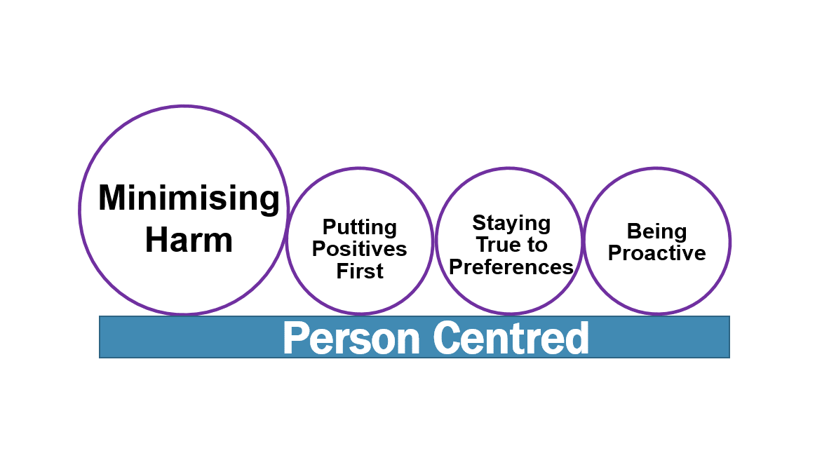

Minimising Harm
Minimising Harm
Karen is trying to eliminate risk. There is a missed opportunity for Susan to try.
Putting Positives First
Minimising Harm

Staying True to Preferences

Susan’s preference is not being enabled. Karen is not being proactive.
Being Proactive
Minimising Harm

Susan’s Smoothie – Part 2 with video
Karen has now completed her Risk Enablement training and has learnt about the 4 Essentials. Watch the video to see how Susan is now involved in making her strawberry smoothie.
Watch the video: Module 3 Extra Activity 3.6 Susan’s Smoothie on the website to see how harm is minimised.

- Complete the remaining blanks in the figure below to describe what is now happening in Susan’s revised scenario with each Essential.

Putting Positives First
Minimising Harm

Minimising Harm
Minimising Harm
Karen uses the hand over hand approach with Susan to cut strawberries.

Susan is making her strawberry smoothie.
Staying True to Preferences

Being Proactive
Minimising Harm

- Thinking about your own work as a disability support worker, can you remember a time when you or someone you work with put too much importance on minimising harm? Explain the scenario, the outcomes and your thoughts about the situation.
Write your response in the box below:

If you have any questions about this module, or would like some further guidance about the activities, you can send an enquiry using the Contact Form. Suggested responses to the activities are provided in the Resources section. ​

MODULE 4: Risk Enablement in Action

Case Scenario: Cody is Moving out of Home
This case scenario “Cody is moving out of home” is provided to demonstrate how the risk enablement process begins with the 4 Essentials and at the same time, it also considers the aspects of: Working Together, Taking Account of Context and Planning. It ends with being Accountable.

Read through the scenario to learn how the process of risk enablement has been applied to enable Cody to move out of home.
Cody has lived at home with his siblings all of his life and he wants to move out of home with two of his mates from work. Cody is a 23 year-old man with intellectual disability.
His Dad is concerned and thinks that Cody is not being realistic and that he is just following the lead of his friends, but is also aware that saying ‘no’ is not how to deal with this situation.
PERSON CENTRED
Cody wants to move out of home and live with his friends. He wants to experience living away from his family and to see what it is like to be more independent. Cody feels that the time has now come for him to try this.
PUTTING POSITIVES FIRST
Dad acknowledges that like many, it is not uncommon for people of Cody’s age to move out of home. Dad recognises this is a milestone and he explores the idea more with Cody. They have a conversation, and his Dad asks, “Cody, what is it about moving out of home that you like?” This approach exemplifies putting the positives first by exploring the idea with Cody rather than operating from a position of protection and choice alone.
While Cody’s Dad might be unsure, he proceeds to support Cody from a positive position and together they look at all aspects that are important to Cody. They also discuss aspects that are of concern to Cody. These include monitoring his finances and keeping the house clean.

BEING PROACTIVE
While he does not express this to Cody, Dad is feeling anxious and concerned about Cody moving out of home. He has concerns about how he will pay the bills, how he will support himself, how he will prepare meals and look after himself. He is quietly concerned that Cody will be taken advantage of, by his friends or strangers.
However, Dad knows that moving out of home is important to Cody – it is Cody’s choice. Instead of being reactive and saying ‘no’, he reaches out to the parents of Cody’s friends and, together with Cody, they begin planning for ‘moving out of home’. At this stage it is exploration. Dad is working with Cody and not directing. Together, with the other parents and Cody’s friends, they begin to map out what ‘moving out of home’ might look like. Together, they agree that a trial would be good, some sort of pilot, so the three friends can test the waters and see if they like living together and if they can take care of themselves. Together, they begin to plan. Together, they are proactive.

STAYING TRUE TO PREFERENCES
As part of the planning, the families engage a support worker to provide support for 6 weekends. The plan is for the three friends and the support worker to begin to test living together. They consider taking it in turns to live at each other’s family homes for the 6 weekends, however, Cody and his friends feel like this is not what they really want, it’s not what moving out of home would really be like.
The support worker suggests they could try to book an Air B’n’B for 6 consecutive weekends, in a place that is familiar to each of them. Cody and his friends are very good with their mobile phones and enjoy using apps. With the support worker, they book the Air B’n’B and show their parents how to use the app and they communicate with each other on Facebook as they plan their weekends away.
The support worker assists them to think of how they will purchase groceries, do household chores and manage interpersonal conflicts while they are away each weekend. Cody and his friends and the support worker begin the 6 weekends away and experience living away from home.
MINIMISING HARM
By using this approach, by working together, planning and thinking about the context within which this experience is occurring, harm is minimised. After the 6 weekends, Cody decides for himself that it isn’t what he really wanted, that he would prefer to stay at home with his family and to go away with his friends on holiday instead. His friends decide to move out of home and move in together and they continue to keep in touch. Cody has decided that he would still like to move out of home in the future, just not right now.
ACCOUNTABILITY
Ultimately, Cody decided to stay at home with his family.
The process that was taken to reach this outcome for Cody included:
- Putting Positives First: Exploring the idea of his move with his Dad
- Being Proactive: Cody’s Dad engaged in discussions with Cody, Cody’s friends and the parents of Cody’s friends to explore ways to assist in Cody’s move. This included agreeing on a trial move.
- Staying True to Preferences: Cody’s preference was to move out of home. Some alternate suggestions were offered, so as to ‘reshape’ the preference (e.g., living at each friends’ house on 6 weekends). The disability support worker suggests booking an Air BnB for 6 consecutive weekends.
- Minimising Harm: there were many potential risks for Cody – including whether he would be able to look after himself, pay bills, and that he might be taken advantage of when he moved out of home. Harm was minimized through careful planning and with discussions about this with his disability support worker and his friends.

ACTIVITY 4.1

- What are considered to be the “risks” in Cody’s scenario?
Write your response in the box below:

- List the people who “Worked Together” in Cody’s scenario. Examples have been provided for you.
Write your response in the box below:
- The person – Cody
- Cody’s Dad

- Describe what needed to be considered as part of the “Context” in Cody’s scenario. Examples have been provided for you.
Write your response in the box below:
- Financial: Costs associated with renting
- Access: Location of new place of living

- Describe the type of “Planning” that was undertaken in Cody’s scenario. Examples have been provided for you.
Write your response in the box below:
- Discussions around re-shaping Cody’s preference
- Engaging a support worker

Case Scenario: Angela’s Birthday Cake

This case scenario “Angela’s Birthday Cake” is provided to demonstrate how the risk enablement process begins with the 4 Essentials and, at the same time, it also considers the aspects of: Working Together, Taking Account of Context and Planning. It ends with being Accountable.

Read through the scenario to learn how the process of risk enablement has been applied.
Angela is a 53 year-old woman with intellectual disability. She really enjoys eating sweet foods, especially cake. Angela has Type II diabetes and takes two different types of oral medication (oral hypoglycaemic medication) to keep her blood glucose levels in control. Mostly, Angela does control her diabetes well, though her recent blood test results revealed her glucose control was not optimal. Her general practitioner made some changes to her diabetes medication management plan which Angela has been following for the past fortnight.
Next week it is her birthday and she has requested to have a birthday cake at her party. Her friends and family are coming to her home to celebrate with her. Angela lives in a group home that she shares with three other people where there are 24-hour support staff.
Her disability support worker, Joan, is concerned about Angela eating cake because of her diabetes. She is further concerned about Angela eating other foods at the party which could affect her diabetes control.

PERSON CENTRED
Angela wants a cake that she will have at her birthday party to share with family and friends.
PUTTING POSITIVES FIRST
Rather than operating from a ‘protection’ perspective, Joan, asks Angela what type of cake she would like to have. Angela says that her preference is to have a chocolate cake. Joan recognises that this is a special event for Angela, and puts positives first by not seeking to eliminate the risk that eating chocolate cake could have on Angela’s blood glucose levels.

BEING PROACTIVE
Joan is quietly concerned about Angela eating foods at her party that will affect her blood glucose levels and then her overall diabetes control. Angela could become unwell and then Joan is aware that she will have to explain what happened to her organisation.
Joan discusses with Angela that it would be a good idea to contact her diabetes educator to discuss food choices for her party. Angela agrees, and they organise a meeting with the three of them – Angela, Joan and the diabetes educator. At the meeting, the diabetes educator explains that Angela has generally good control over her blood glucose levels since the recent change to her management plan by her general practitioner. She further explains that, in this situation, Angela having a slice of chocolate cake on her birthday will unlikely have consequences that will lead to hospitalisation.
STAYING TRUE TO PREFERENCES
As part of the planning meeting, Angela’s diabetes educator suggests that the cake can be a small or medium-sized one, so that portion sizes are not too large and that it is shared amongst the guests. She also recommends having one with little or no icing so as to reduce sugar intake. Angela says that she does not mind the size of the cake, so long as it is chocolate and has sparklers on the top.
During the meeting, and with Angela’s permission, the diabetes educator phones Angela’s dietitian to be sure that she has not missed anything. The dietitian suggests that a piece of cake is unlikely to cause harm. With the concern about other foods Angela may eat at her party, the dietitian suggests that the party menu will need to be well planned in advance. It is suggested that foods with low carbohydrates are served. These include, for example, diet jelly and diet soft drink alternatives.
The dietitian also advises that Angela take a brief 30-minute walk following her party and again before bed if possible. This sort of approach will have the biggest impact on lowering her glucose levels the next morning.
The dietitian further suggests that Angela’s blood glucose levels are checked in-house before she goes to bed following the party and again early next morning, so that these are monitored a little more closely. If Angela’s morning glucose readings are found to be high compared with her usual readings, then it is suggested that Angela take another 30 minute walk to reduce it. Her glucose levels can be checked again following the walk, and if there is further concern, then Angela’s general practitioner can be contacted for advice.
It is further recommended that for meals during the week following and leading up to Angela’s party, that her meals include salads and vegetables, so as to keep her glucose levels stable in as much as possible around her event. Angela is agreeable to the change in her meals for the next fortnight as she understands that this is required for her health. Joan informs the Practice Leader of the need to make these changes to Angela’s weekly meal plans.

MINIMISING HARM
Denying Angela a cake for her birthday celebration could cause harm to her psychosocial well-being – she could, for example, become sad, lack motivation and enthusiasm if her request was denied. She might not enjoy her party as much. Trying to eliminate risk will bring with it its own risk. Much planning has gone into ensuring Angela’s preferences are supported and risk to her glucose control is minimised.
Angela had a lovely birthday celebration, ate a slice of chocolate cake and took a brief walk with her guests after her party, another walk with her support worker before bed and again the next morning. Although her blood glucose levels experienced a small rise before bed, her readings were back to within normal ranges the following day.
ACCOUNTABILITY
The process that was taken to reach this outcome for Angela included:
- Putting Positives First: Discussing with Angela what type of cake she would like.
- Being Proactive: Instead of saying ‘no’ to Angela having a cake, careful planning was undertaken by Joan, who worked with Angela and together they discussed Angela’s preferences with the relevant people.
- Staying True to Preferences: Angela’s preference was to have a chocolate cake. A smaller sized option was suggested to Angela, but her preference for a cake was maintained.
- Minimising Harm: it is often difficult when trying to balance enabling risk while ensuring positive outcomes. In this situation, Joan was very careful to involve Angela and plan the party menu in advance. Together, they sought advice from diabetic professionals, and the advice provided included: low sugar food options at the party, checking of glucose levels and additional exercise in the form of walking. Also, Angela’s weekly meal plans included adding extra vegetables and salads to help stabilize her glucose as much as possible before and after her party took place.

ACTIVITY 4.2

- What are considered to be the “risks” in Angela’s scenario?
Write your response in the box below:

- List the people who “Worked Together” in Angela’s scenario. Examples have been provided for you.
Write your response in the box below:
- The person – Angela
- Disability Support worker – Joan
- Describe what needed to be considered as part of the “Context” in Angela’s scenario. Examples have been provided for you.
Write your response in the box below:
- Catering: Foods Angela can eat, size of her cake
- Health: The type of blood glucose control Angela has normally

- Describe the type of “Planning” that was undertaken in Angela’s scenario. Examples have been provided for you.
Write your response in the box below:
- Meal planning during the week to include vegetables and salad
- Added blood glucose level readings

ACTIVITY 4.3: Shane’s New Start

Read Shane’s scenario below, then answer the questions.

Shane has recently been in jail and is currently on parole. Shane’s parole conditions state he is required to have stable accommodation. Shane wants to live in his home town with his brother, Macca, who is a fly-in, fly-out worker in another state.
Macca is away from home a lot with work but would also like Shane to live with him. In the past, Shane has felt lonely and isolated and ended up with a group of peers who led him into criminal activity.
Shane has a moderate intellectual disability and has had part-time jobs in the past. He particularly enjoyed working on cars and with mechanics.
A high priority for Shane is not going back to jail.
Macca is leaving in 12-months’ time and will be taking up a new job in the local area. You are working with Shane as his disability support worker.
- What are considered to be the “risks” in Shane’s scenario?
Write your response in the box below:

- How will you be person centred with Shane?
Write your response in the box below:

- Thinking about the 4 Essentials, and the Risk Enablement Process, how will you enable Shane’s preference? Describe what you would consider for each of the Essentials below.

  - Putting Positives First

Write your response in the box below:

  - Being Proactive

Write your response in the box below:

  - Staying True to Preferences

Write your response in the box below:

  - Minimising Harm

Write your response in the box below:

You have now thought about the 4 Essentials in relation to Shane’s scenario. The questions below ask you to think about the process of risk enablement.
- Can you find examples of how you have worked together to enable Shane’s preference?

Write your response in the box below:

- Explain whether you had taken account of context to enable Shane’s preference.
Write your response in the box below:

- Can you find examples of the planning you did to enable Shane’s preference?

Write your response in the box below:

- Briefly describe what you did to enable Shane’s preference. You can write your answer next to each Essential below.

Write your response in the box below:
- Putting Positives First:

- Being Proactive:

- Staying True to Preferences:

- Minimising Harm:

ACTIVITY 4.4: Chloe Catches the Train

Read Chloe’s scenario below, then answer the questions.

Chloe catches the train to work each day and has been doing so for many years. Recently, however, a new ticketing system has been introduced where train commuters have to ‘touch on’ and ‘touch off’. Chloe often forgets to do so and, as a result, has incurred large fines.
The support workers are now considering driving Chloe to work, or arranging a bus to come and pick her up.
Chloe is upset and frustrated as she enjoys catching the train but does not seem to understand she cannot afford to keep incurring fines.
Her support worker says, “Well, it’s tough, I know, but she just has to realise she can’t catch the train anymore. If she’s going to choose not to touch on and off, then that’s the consequence. No more train, it’s just too risky.”

- What is considered to be the “risk” in Chloe’s scenario?

Write your response in the box below:

- How will you be person centred with Chloe?

Write your response in the box below:

- Thinking about the 4 Essentials, and the Risk Enablement Process, how will you enable Chloe’s preference to catch the train? Describe what you would consider for each of the Essentials below.

  - Putting Positives First

Write your response in the box below:

  - Being Proactive

Write your response in the box below:

  - Staying True to Preferences

Write your response in the box below:

  - Minimising Harm

Write your response in the box below:

You have now thought about the 4 Essentials in relation to Chloe’s scenario. The questions below ask you to think about the process of risk enablement.

- Can you find examples of how you have worked together to enable Chloe to catch the train?

Write your response in the box below:

- Explain whether you had taken account of context to enable Chloe to catch the train.

Write your response in the box below:

- Can you find examples of the planning you did to enable Chloe’s preference?

Write your response in the box below:

- Briefly describe what you did to support Chloe to catch the train. You can write your answer next to each Essential below.

Write your response in the box below:
- Putting Positives First:

- Being Proactive:

- Staying True to Preferences:

- Minimising Harm:

ACTIVITY 4.5: Scissors for Romeo

Read Romeo’s scenario below, then answer the questions.

Romeo likes to cut out pictures from magazines for his scrapbook but staff say it is too dangerous for him to have a pair of scissors. Staff keep the scissors in the locked office because if Romeo sees the scissors he will try to grab them.
Romeo has developed a reputation for behaviours of concern and staff have asked for a referral to the behaviour support team to stop Romeo from grabbing the scissors.

- What is considered to be the “risk” in Romeo’s scenario?

Write your response in the box below:

- How will you be person centred with Romeo?

Write your response in the box below:

- Thinking about the 4 Essentials, and the Risk Enablement Process, how will you enable Romeo’s preference to have a pair of scissors? Describe what you would consider for each of the Essentials below.

  - Putting Positives First

Write your response in the box below:

  - Being Proactive

Write your response in the box below:

  - Staying True to Preferences

Write your response in the box below:

  - Minimising Harm

Write your response in the box below:

You have now thought about the 4 Essentials in relation to Romeo’s scenario. The questions below ask you to think about the process of risk enablement.

- Can you find examples of how you have worked together to enable Romeo’s preference?
Write your response in the box below:

- Explain whether you had taken account of context to enable Romeo’s preference.

Write your response in the box below:

- Can you find examples of the planning you did to enable Romeo’s preference?

Write your response in the box below:

- Briefly describe what did to support Romeo to have a pair of scissors. You can write your answer next to each Essential below.

Write your response in the box below:
- Putting Positives First:

- Being Proactive:

- Staying True to Preferences:

- Minimising Harm:

If you have any questions about this module, or would like some further guidance about the activities, you can send an enquiry using the Contact Form. Suggested responses to the activities are provided in the Resources section. ​

MODULE 5: Being Someone who Enables Risk

ACTIVITY 5.1: Experiences from risk enablement

Watch the video and then do the following activities
Watch the video: Module 5: Experiences of disability support workers on the website. This video provides quotes from disability support workers who share their experiences after putting risk enablement training into practice.

- What were the main experiences the disability support workers had after enabling risk?

Write your response in the box below:

- How does reading these quotes make you feel about putting risk enablement into practice for someone you support?

Write your response in the box below:

ACTIVITY 5.2: Application

Now that you have learnt how to enable risk, it is now time to think about how you will apply what you have learned.
Think about a person you support. How will you enable them to take a risk? You will need to think about how you will apply the 4 Essentials, and the aspects of Working Together, Planning, Taking Account of Context to their scenario. Finally, demonstrate your Accountability by describing the process you took.
Follow the questions below to help you through the risk enablement process for the person you support.

- Briefly write the person’s scenario below. What is the activity that they want to do that involves risk?

Write your response in the box below:

- What is the risk in your person’s situation?
Write your response in the box below:

Work through the questions below to describe how you will apply the 4 Essentials.

- Describe how you will Put Positives First to enable the person you support to take part in their risky activity.

Write your response in the box below:

- Describe how you will Be Proactive to enable the risk for the person you support.

Write your response in the box below:

- Describe how you will Stay True to Preferences to enable the risk for the person you support.

Write your response in the box below:

- Describe how you will Minimise Harm to enable the risk for the person you support.

Write your response in the box below:

Work through the questions below to describe how you will apply the aspects that you must consider as part of the risk enablement process.

- Describe whether you worked with others to enable the risk for the person you support. List the people you worked with.

Write your response in the box below:

- Did you consider the context to enable the risk for the person you support? Explain.

Write your response in the box below:

- Did you engage in planning to enable the risk for the person you support? Explain.

Write your response in the box below:

- In order to be accountable, you need to be able to describe what you did. Briefly summarise what you did above to enable risk for the person you support.

Write your response in the box below:

ACTIVITY 5.3: Organisational Process and Support

- Talk to your manager or supervisor about how to locate your organisation’s policy and/or procedure that relates to risk enablement. Note: it is possible that it might be called something like: Client Safety Policy or Duty of Care Policy, for example.

Write your response in the box below:

- If someone you support is harmed while being supported to undertake a risky activity, describe how your organisation will support you through this process. Note: this might be a good topic to discuss openly at a staff meeting.

Write your response in the box below:

If you have any questions about this module, or would like some further guidance about the activities, you can send an enquiry using the Contact Form. Suggested responses to the activities are provided in the Resources section. ​

